COMPOUND MEASURES
Pearson Edexcel - Monday 8 June 2020 - Paper 3 (Calculator) Foundation Tier

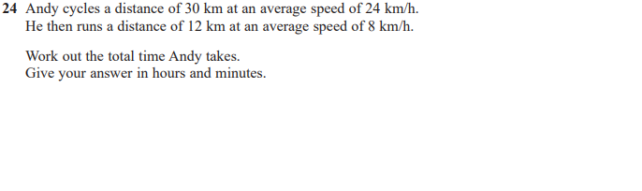

Pearson Edexcel - Monday 12 November 2018 - Paper 3 (Calculator) Foundation Tier

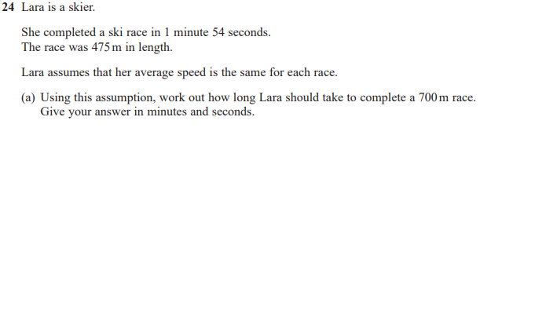
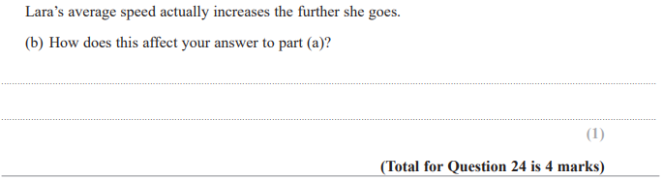

Pearson Edexcel - Thursday 24 May 2018 - Paper 1 (Non-Calculator) Foundation Tier

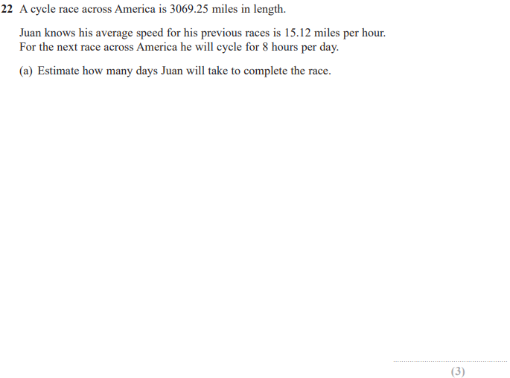
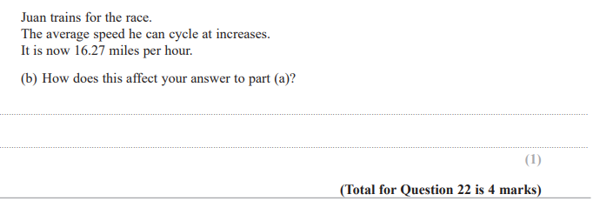

Pearson Edexcel - Thursday 7 June 2018 - Paper 2 (Calculator) Foundation Tier

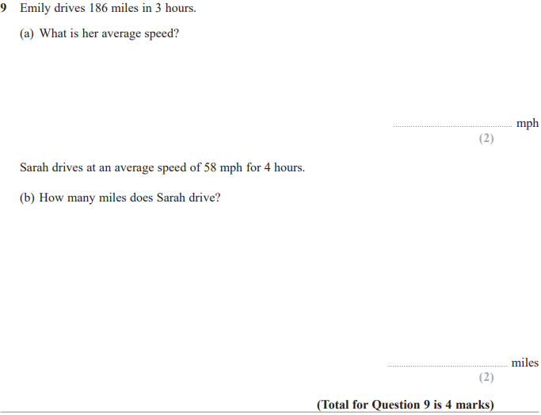

Pearson Edexcel - Wednesday 8 November 2017 - Paper 3 (Calculator) Foundation Tier

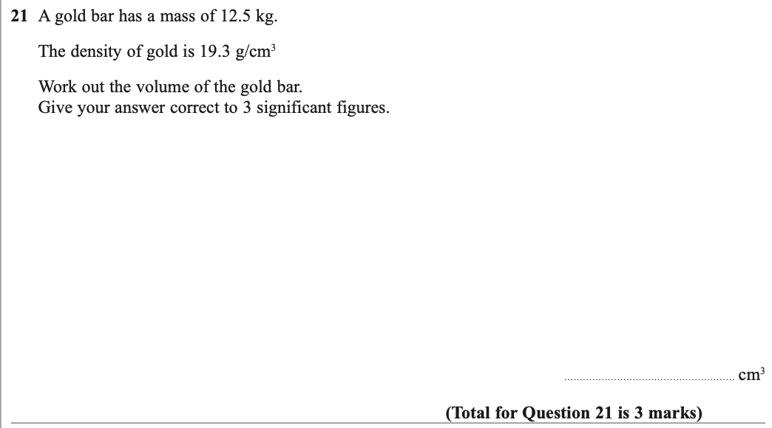

Pearson Edexcel – Specimen 2 - Paper 1 (Non-Calculator) Foundation Tier

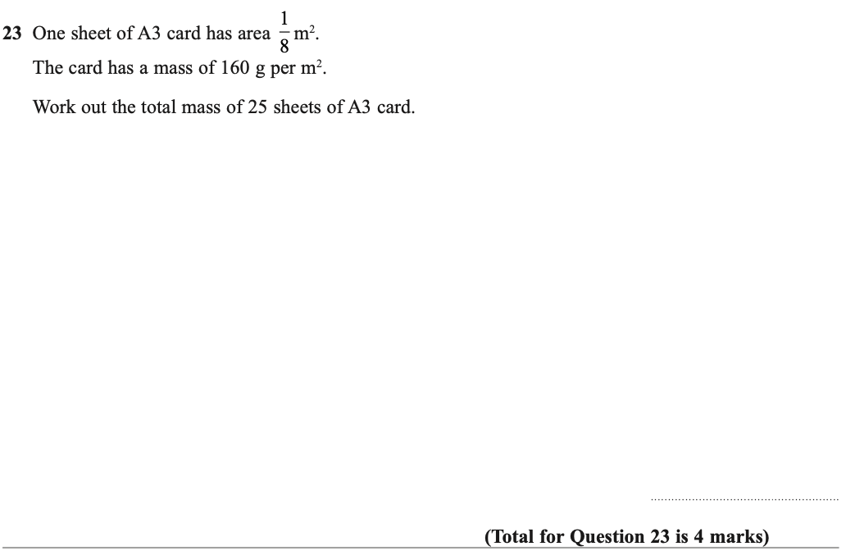

Pearson Edexcel – Specimen 2 - Paper 2 (Calculator) Foundation Tier

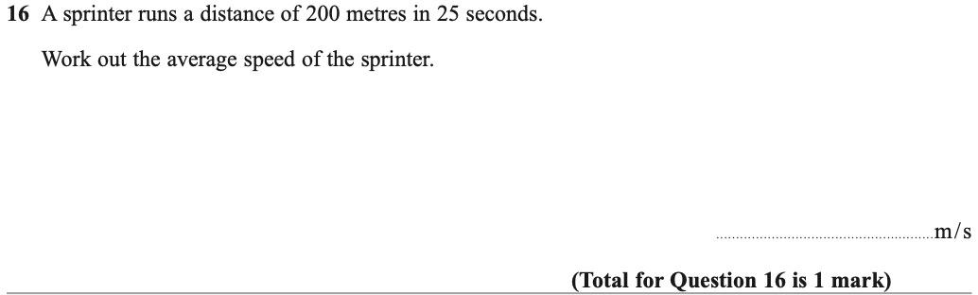

Pearson Edexcel – Specimen 1 - Paper 1 (Non-Calculator) Foundation Tier

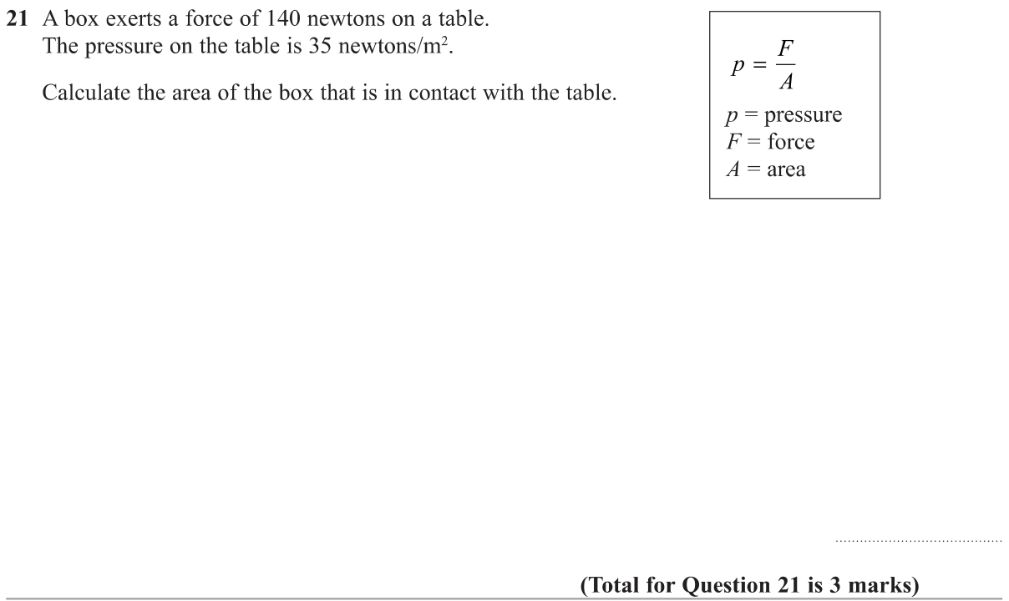

Pearson Edexcel – Specimen 1 - Paper 3 (Calculator) Foundation Tier

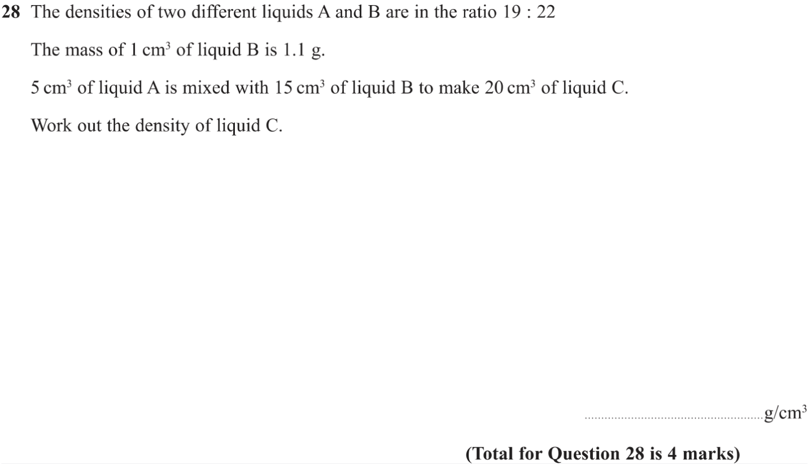

Pearson Edexcel – Sample Paper 1 (Non-Calculator) Foundation Tier
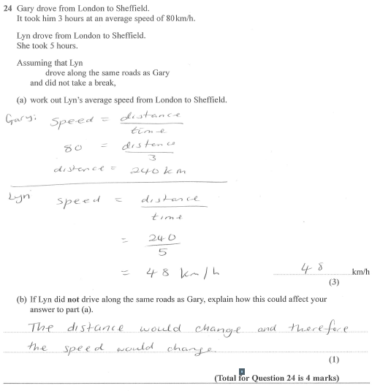

OCR – Tuesday 03 November 2020- Morning - Paper 1 (Calculator) Foundation Tier

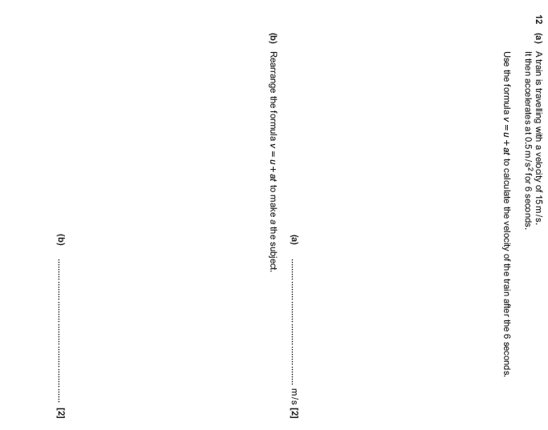

OCR November 09 November 2020- Morning (Calculator) Foundation Tier

OCR Tuesday 5 November 2019 – Morning (Calculator) Foundation Tier
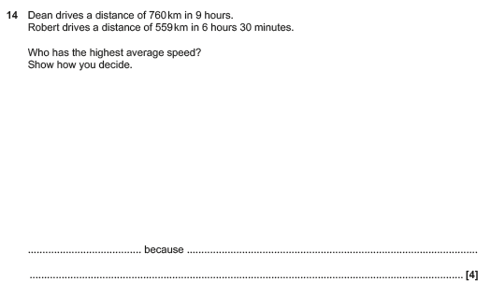

OCR Thursday 07 November 2019- Morning (Non-Calculator) Foundation Tier
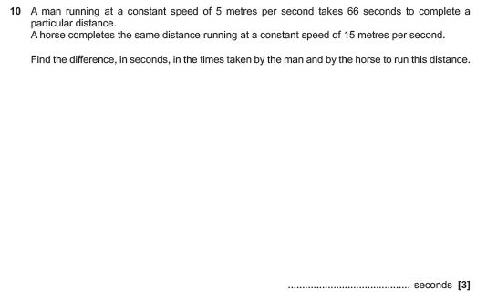

OCR Tuesday 21 May 2019 – Morning (Calculator) Foundation Tier
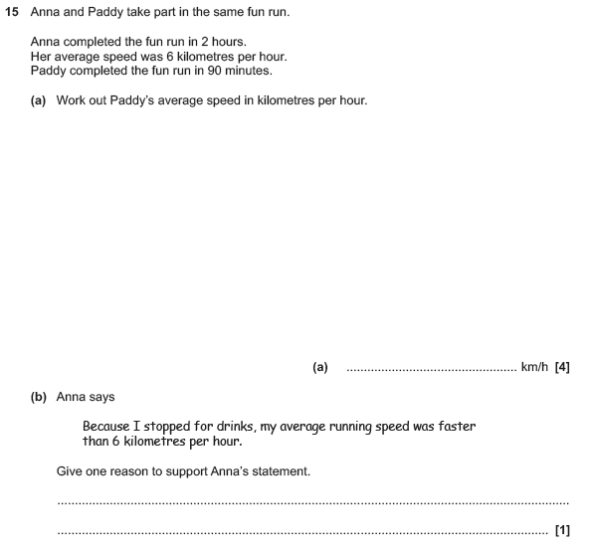

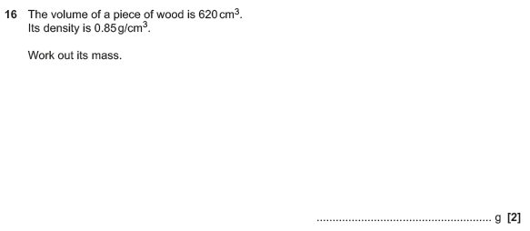

OCR Tuesday 11 June 2019 – Morning (Calculator) Foundation Tier
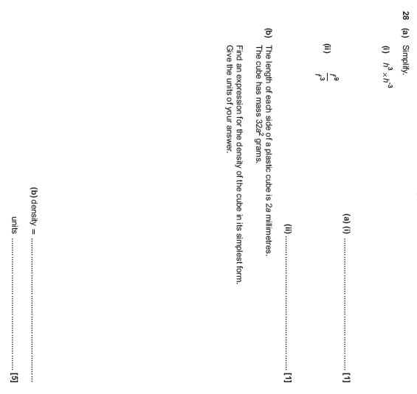

OCR Monday 12 November 2018 – Morning (Calculator) Foundation Tier
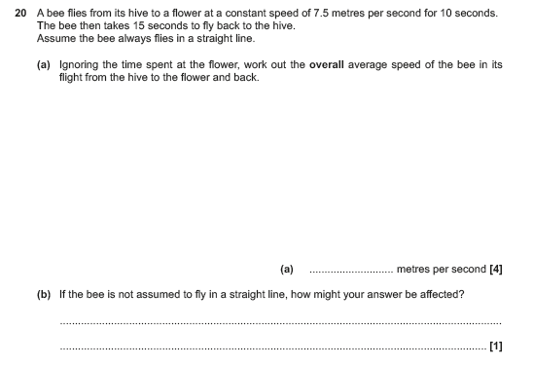

OCR Thursday 7 June 2018 – Morning (Non Calculator) Foundation Tier
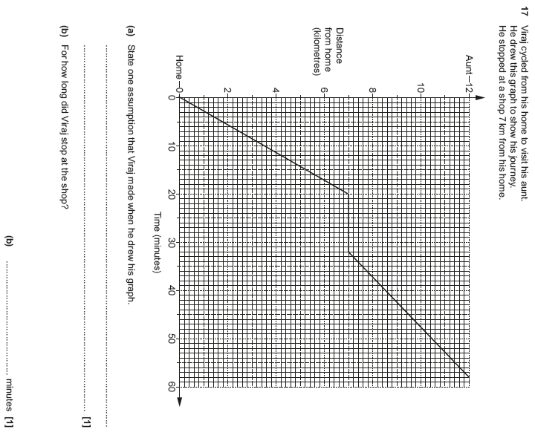

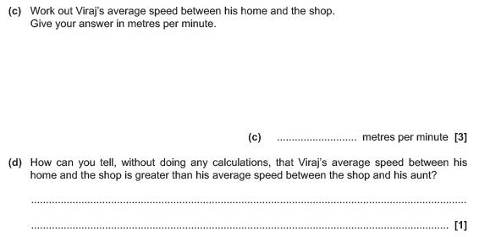

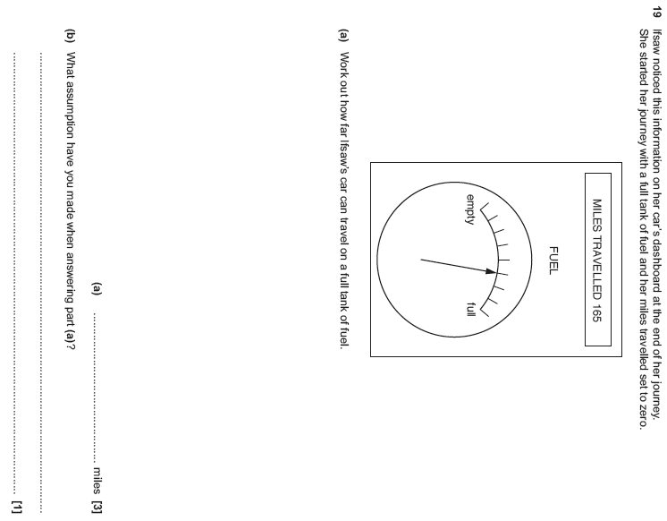

OCR Monday 6 November 2017– Morning (Calculator) Foundation Tier
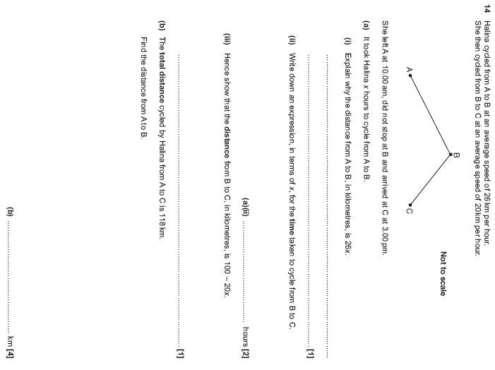

OCR Tuesday 13 June 2017 – Morning (Calculator) Foundation Tier

